Chapter 19, Problem 17.

Determine the z and y parameters for the circuit in Fig.19.78.
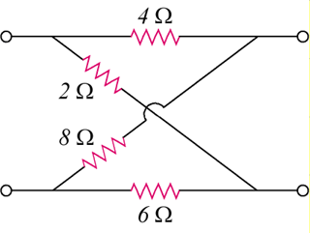
12 Ω
16 Ω
4 Ω
8 Ω

Figure 19.78
For Prob. 19.17.

